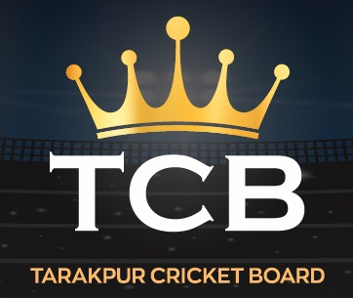**T10 Super League Season 3 - RULE BOOK**

**1. Match Format**

* Each inning will consist of **10 overs**.
* Matches will be played with the **Wilson Tour Championship ball**, and a new ball will be used for each inning.
* Ball change depends on Umpire

**2. Powerplay Rules**

* **3 overs of Powerplay**:

a. The first 2 overs are compulsory.  
b. The third Powerplay over can be taken at the batting team's discretion within the **7th-10th overs**.  
c. If not utilized earlier, the **10th over** will automatically be a Powerplay.  
d. During Powerplay, a maximum of **2 fielders** are allowed outside the 30-yard circle.

**3. Bowling Restrictions -** Each bowler is allowed to bowl a maximum of **2 overs per inning**.

**4. Bowling Action Controversy** - Any disputes regarding a bowler's action will be resolved solely at the umpire’s and committee decision.

**5. Pre-Match Protocol**

* Captains and teams must report at least **30 minutes before the match timing** for the toss, If not then will be responsible for losing batting powerplay in that game.
* Matches must begin at the scheduled time; any delays will result in penalties.

**6.** **Jersey Rule** – Player Should wear jersey’s compulsory for every match , NO EXCEPTIONS

**7. Tournament Format**

* The tournament will feature **2 groups**, each containing **6 teams**.
* Each team will play **4 league matches**.
* From each group, the **top 3 teams** will qualify for the next stage.

**8. Player Participation** - Every player must play in at least **1 league stage match**.

**9. Time Management** - An innings timer will be enforced. Teams exceeding the allotted time will face penalties.

**10. Controversies and Disputes** - All controversies will be resolved by the umpire and tournament committee. Their decision will be **final and binding**.

**11. Tie Situations**

* **League Stage**: If a match ends in a tie, both teams will receive **1 point**.
* **Knockout Stage**: In case of a tie, there will be a **Super Over** until a result is achieved.

**12. Decision Review System (DRS)**

* Each team is allowed **1 DRS per inning** (This feature is included as matches will be **broadcast on YouTube**)

**13. General Rules -** All other rules will follow standard cricket regulations.

**The league aims to promote unity and entertainment. Players are expected to compete fairly and in good spirit.**

**Let the battle begin!**